IBM CLOUD DASHBOARD

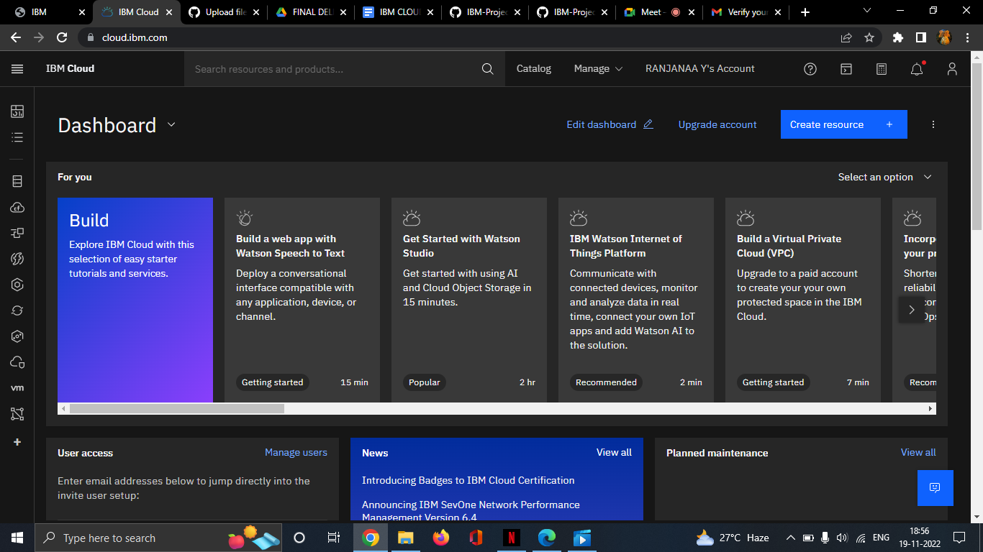

IBM COGNOS ACCOUNT

